Hospitality House Grass Valley

Our Core Organizational Values
Home is where the hearts is. Because we all long for warmth, comfort, and safety, few losses strike more deeply into our lives than the loss of home. At Hospitality House, our hearts are with the homeless.
- We show compassionate behavior toward all people at all times.
- We work supportively with one another in a spirit of mutual appreciation for talents and abilities.
- We dedicate ourselves to the mission of the organization, manifesting in practical actions that turn short-and long-term goals into realities.
- We practice careful, sincere, and respectful listening that leads to mutual understanding, consensus building, and organizational stability.
- We strive for the courage and integrity to uphold the civil rights of all, even when doing so may offend those who are opposed to upholding such rights.
- We practice competent decision making in all areas that sustain the organization over time.
- We participate in extensive community involvement in a spirit of radical inclusiveness.

Hospitality House is proud to offer two programs that support the healing and recovery of homeless patients in need of extended care: the Recuperate Care Dorm and Rest, Recovery and Prevention Project, both of which fall under the Community Respite Program.

Recuperative Care Dorm
In partnership with County of Nevada and Dignity Health Sierra Memorial Hospital, Hospitality House opened the four-bed Recuperative Care Dormitory in October 2018.
The Recuperative Care Dormitory is designed exclusively to welcome homeless patients released from Sierra Nevada Memorial Hospital to Hospitality House where they can continue to rest and recuperate from their ailments and injuries, 24 hours a day, seven days a week at the shelter. In addition to resting at the shelter, in-house physical therapy has also been provided to guests in Recuperative Care as needed through the hospital, reducing the number of repeat hospital visits.
“Dignity Health recognizes the need for medical respite for those experiencing homelessness in the communities we serve,” said Brian Evans, President of Sierra Nevada Memorial Hospital, in reflecting on the program’s impact after just six months open. “We are thrilled about the program’s success to date and so thankful for our partnership with the County of Nevada and Hospitality House.”
The program has been so widely successful that it inspired the creation of the Rest, Recovery and Prevention Project.

Rest, Recovery and Prevention Project (RRPP)
In 2020, Hospitality House was awarded the County Medical Services Program Local Indigent Care Needs (CMSP LICN), which created the RRPP program. Thanks to CMSP LICN, the new three-year program provides ten 24/7 medical respite beds year-round to those in need of a safe place to rest and recover, including ongoing case management, nutritional meals, housing support, and more.
Referrals for RRPP include Chapa-De Indian Health, Sierra Nevada Memorial Hospital, Nevada County Behavioral Health, Public Health, Housing and Child Support Services, Probation, other social service non-profits, as well as self referrals.
Hospitality House is grateful to all of its partners who came forward to make both programs possible.

Get in Touch

Families/individuals who lost their housing may be able to receive short term help with their rent to enable them to move in to new housing if they are homeless.

Eligibility requirements include:
- Rapid re-housing funding and stabilization services will be available to eligible households who are literally homeless to help them move into permanent housing and achieve housing stability.
- Current household income must be 30% of Nevada County Median or less at the time of the annual evaluation. .
- Families/individuals must have a reasonable plan that will enable them to keep their housing long term.
- Must lack sufficient resources and support networks necessary to retain housing without assistance from the Rapid Re-Housing program.

Families/individuals who meet the guidelines may receive assistance with:
- Short Term Rental Assistance (0-3 months)
- Medium Term Rental Assistance (4-18 months)
- Security Deposits
- Utility Deposits and Payments
- Moving Costs
- Legal services necessary to resolve a legal problem that prohibits participant from obtaining or maintaining permanent housing
- Credit repair
- Support in developing a housing stabilization plan that may include: budgeting, linkage to resources, housing search support and related assistance as appropriate to the family situation

In order to receive rental assistance, the following rules apply:
- Rental assistance cannot be provided for a unit unless the rent for that unit is at or below the Fair Market Rent limit, established by HUD.
- The rent charged for a unit must be reasonable in relation to rents currently being charged for comparable units in the private unassisted market and must not be in excess of rents currently being charged by the owner for comparable unassisted units. See 24 CFR 574.320.
- The rental unit must meet minimum habitability standards found at 24 CFR 576.403.
- There must be a rental assistance agreement and lease between property manager and tenant as well as the owner of property and ESG sub-recipient.
- No rental assistance may be made to an individual or family that is receiving rental assistance from another public source for the same time period, and
- Rental assistance may not be provided to a participant who is currently receiving replacement housing payments under Uniform Relocation Assistance.
- Participant will be evaluated by case manager not less than once annually for eligibility and the type and amount of assistance the participant needs.
- Participant will also be evaluated by case manager when the participant’s income or other circumstances change that affects the participants need for Rapid Re-Housing assistance.
- To remain eligible for assistance the participant must lack sufficient resources and support networks necessary to retain housing without assistance from the Rapid Re-Housing program.
- Failure to meet eligibility criteria, follow individual housing plan; including attending scheduled meetings with case managers may result in termination from the Rapid Re-Housing program.
- Case manager will provide clear guidelines and expectations in writing and in interviews with the program participant in order to help the participant maintain eligibility to the program.
- Upon termination, participants will be given written notice stating reasons for termination from the program and appeal process.
For more information on this program, Please contact Hospitality House at (530) 271-7144 and ask to speak to a housing case manager.

Helping Homeless Individuals Receive Job Training and Support
Awarded in April 2020, the BBTE grant helped provide one dedicated case manager responsible for helping our guests find jobs in our community. The grant not only helped enhance the existing culinary job training program offered at Hospitality House, but birthed two new job training programs in 2021: computer literacy and and facilities maintenance. The program also leverages our preexisting Adult Reentry Grant Program, helping homeless individuals with prior offenses receive job training, employment assistance and housing support.
For more information, please contact Tyson Powers at 530.798.6465 or tpowers@hhshelter.org.

Helping Homeless Individuals with Minor Offenses Reach Housing and Sustainability
Hospitality House applied for the Adult Reentry Grant Program (ARGP) in 2019 which, in the easiest of terms, means since being awarded this grant, we help people with minor criminal offenses who are also struggling with homelessness. Ten beds are available year-round at our shelter, Utah’s Place, for stabilization and assistance as well as financial aid to reach permanent housing. The program aims to reduce recidivism and increase returns to housing and self-sufficiency by offering case management, rapid rehousing, job training and long-term wraparound services to ensure each individual feels supported as they transition back into society.
IMPORTANT: This program helps individuals with minor criminal offenses only (non-violent and non-sexual).
For more information or to see if you qualify, please contact Elida Ramirez, ARGP Case Manager, at (530) 615-6454.

The Pet Program
The Pet Program is designed to help homeless pet owners receive shelter and services at Hospitality House with their pet at their side. In addition to shelter, pets are receiving food, licensing, veterinary care, vaccinations, spay and neuter, wellness checks, flea and tick treatment and medications and medical care as needed. With people and pets together at the shelter, they can now benefit from the shelter’s programming to help transition back into housing, which is the ultimate goal.
Previously, if she/he owned an animal, they would have to choose whether to leave their loved one behind in order to move forward with shelter and expanded support or stay with their pet on the streets.
To help people with pets, donors of Hospitality House responded by opening the Pet Program at Hospitality House. Funding for the program began in September 2019 and the program came to fruition on New Year’s Day 2020. Today, the program continues to receive funding support from founding donors and is also sustained through grant awards.
To get support from the Pet Program, please call our shelter at (530) 271-7144.

About Hospitality House Serves
Hundreds of individuals per year utilize the Hospitality House Community Shelter. Many of these individuals are disabled, veterans, and single parents who want to provide their children with safe and stable homes. Many lack the career skills necessary to find and maintain living wage employment. Others suffer from low self-esteem or a disabling condition that doesn’t permit them to work in careers many have spent their lives doing. That’s why the Hospitality House Serves Culinary Job Training Program is so important.

Hospitality House Serves helps people out of the grinding cycle of poverty by providing a 12-week culinary job training program. This program empowers homeless adults to achieve employment and self-sufficiency goals through life skills instruction, internships, job-placement assistance, housing case management, empathy and hope.
Students begin their six week classes with little or no knowledge of working in a kitchen and at the end of six weeks they will be equipped with the skills needed to be competitive candidates for employment in the food and hospitality industry.

Hospitality House Community Serves Program
We would like to invite local organizations, clubs, businesses, community leaders, and faith communities to observe our program first hand by serving an evening meal to shelter guests. This meal will be prepared by our kitchen manager and chef, Chris Fagen, and our Hospitality House Serves Culinary Job Training students. Your group of 4-6 people will arrive at 5:00 p.m. Dinner is served from 5:45 until 6:30.
If you would like to participate, please contact Chef Chris Fagen at chris@hhshelter.org

Affordable Housing and Day Services Center
Jan 22, 2019
Hospitality House recently teamed up with County of Nevada, the City of Grass Valley and Regional Housing Authority with a shared goal to build a welcoming day services center and 41-units of affordable housing. This project aligns with Hospitality House’s mission to assist homeless residents in transitioning from homelessness to housing, and the long-term vision of providing permanent supportive housing to County residents. The Nevada County Board of Supervisors gave final approval on the project on Jan. 22, 2019, which means Hospitality House and its partners are moving forward to bring this project to fruition.

The center, known as Brunswick Commons Resource Center, will include supportive mental health services for Nevada County residents in a location near essential services, such as hospitals, employment, grocery stores, and other allied community partners. Visitors will be able to take classes, meet with case managers, receive medical referrals, get therapy, look for jobs, fill out paperwork in addition to accessing bathrooms, showers and food. Additionally, nine units of transitional housing will be available to assist individuals who are preparing for entry into permanent housing.

AFFORDABLE HOUSING (Brunswick Commons)
The project includes plans for affordable housing called Brunswick Commons, comprising 41 units, 12 of which will be designed exclusively for those chronically homeless and mentally ill (this is a No Place Like Home requirement and potential funding source of the project). One unit will also be designated for a complex manager.

FREQUENTLY ASKED QUESTIONS
HOW DID THE PROJECT ORIGINATE?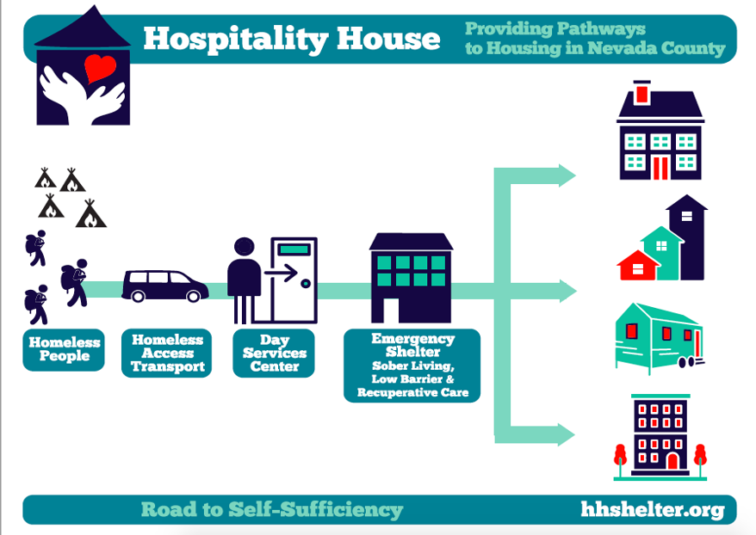
Building a day services center and affordable housing is a collective idea made possible by Hospitality House, County of Nevada, City of Grass Valley and Regional Housing Authority. This vision is coming to life because of dedicated community partners who saw a need to do more to help its homeless population. Through extensive creative brainstorming and workshops, a plan was put in place to make an idea a reality.

Extensive research has gone into this project and the opposite has been found true. This project follows a Housing First model, which is an evidence-based approach to quickly connect individuals and families experiencing homelessness to permanent housing without preconditions and barriers to entry, such as sobriety, treatment or service participation requirements. The priority is to immediately transition folks into permanent supportive housing rather than wait until the household’s mental and/or medical health is stabilized.
It may seem simple, but the answer to end homelessness is having a home. The Housing First approach is a proven, successful method in reducing homelessness. In fact, an article written by David Langness in January 2019 appeared in The Union on this subject that includes hard evidence and references to successes in other areas, such as Utah. By following a Housing First approach, Utah decreased its homeless population by 72% percent. That’s a huge number. Read full story and examples of success.

WHY ARE YOU TRYING TO BUILD A DAY SERVICES CENTER AND HOUSING?
Homelessness is a real problem in the community. There are hundreds of people without a home and taking no action does not help the situation. These are your neighbors and they are a part of the community. Helping those in need is a fundamental principle of Hospitality House. In recent months, Hospitality House received support from United Way of Nevada County and County of Nevada and was able to expand its services to connect with homeless residents living on the streets and in camps (these are individuals not currently sheltering at Utah’s Place). Between October and December 2018, the new Street Outreach team has:
- Served 280 people
- Made 970 referrals to other service providers
- Provided 471 unique rides to approximately 85 individuals
- Had 595 conversations with folks in the community in an effort to connect them to services
These stats are based on less than two months worth of data and are strong indicators of a serious problem. By building a day services center and affordable housing, the Hospitality House team and its partners will be able to connect even more people to resources and housing, reducing fire danger from unsupervised camps in the process.

HOW WILL THE PROJECTS BE FUNDED?
If all goes as planned, Brunswick Commons Resource Center will be paid for in part by a Community Development Block Grant, otherwise known as a CDBG. The application request of $3 million will be submitted in February 2019.
Brunswick Commons affordable housing, on the other hand, may be paid in part by No Place Like Home (NPLH). This is a highly collaborative application process between Hospitality House, County of Nevada, the City of Grass Valley, and the Regional Housing Authority. The grant application was submitted on Jan. 30, 2019, and it is anticipated it will take up to 4 months to learn if the application is accepted. If accepted, $2 million will help fund the housing portion of this project.

